User Manuel

Concert Connect

Joseph Ahrendsen

Table of Contents

Contents

Logging in: 3

Browsing upcoming shows: 3

Saving a Concert: 3

Updating an RSVP Status: 4

Deleting a Saved Concert: 4

Creating a New Concert 4

Logging off: 4

# Logging in:

To log in, first click the **login** button on the navigation bar in the top right of the page. From here, you must enter the username and password you used to create your account.

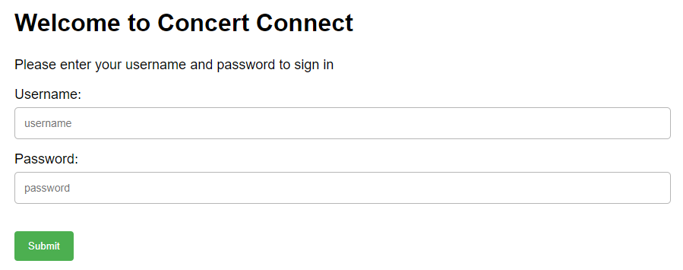

# Browsing upcoming shows:

**1.** From any page, click on the “**Genres**” link on the navigation bar in the top left of the page. There are six genres to choose from: Rock, indie, pop, country, jazz, and rap. To scroll through all available genres, click the arrow on either side of the outside images. Once you find a genre you’re interested in, click the image.

**2.** From here, you will see the upcoming concerts for whichever genre you selected. Click on of the concerts to learn more about it.

**3.** At this point, you will find details for the concert that you chose. Read the section on “Saving a Concert” to learn about how to save events to your profile.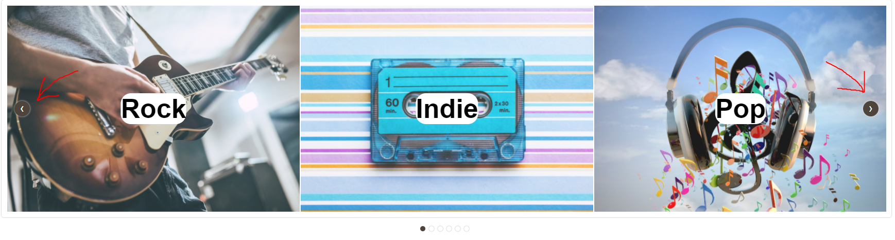

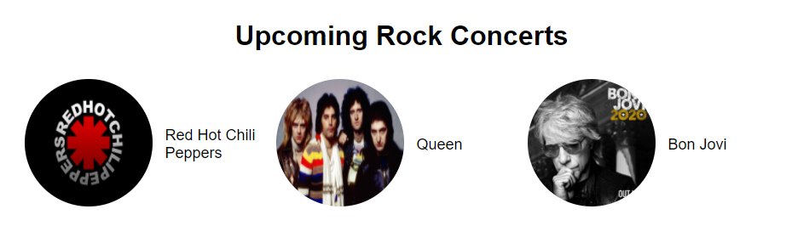

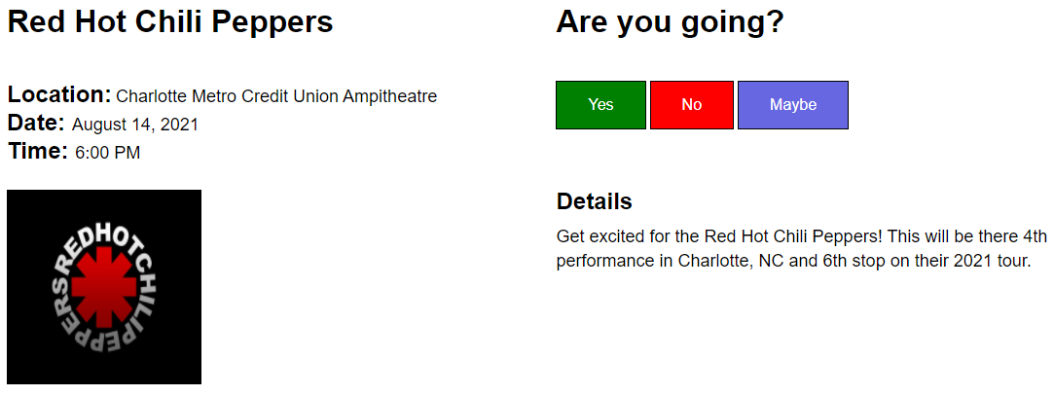

# Saving a Concert:

You must be logged in to save a concert. If not logged in, view the “Logging In” section. To save a concert to your profile, simply click either Yes”, “No”, or “Maybe”. You will then be directed to a list of all your saved concerts.

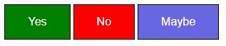

# Updating an RSVP Status:

To update an event status that you have previously saved, click on “**My Connections**”. From there, click the **update** button next to the event you want to modify. You will be redirected to that event page where you can edit your RSVP decision.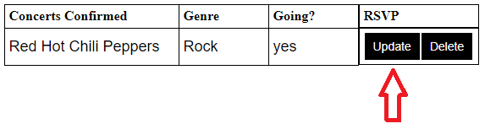

# Deleting a Saved Concert:

To delete an event that you have previously saved, click on the “**My Connections**” link. Next, click the **delete** button next to the event that you want to remove.

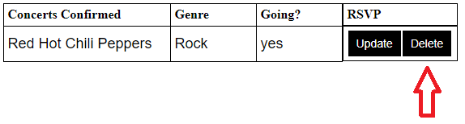

# Creating a New Concert

To create a new concert, you must click on the “**Start a new connection**” link in the top right on the navigation bar. Note, you must be logged in to perform this function. Once on the new connection page, enter the details for your event. Make sure to fill out every field. Once completed, click the submit button and your event will be saved for other users to see. This event will also show up in your saved connections.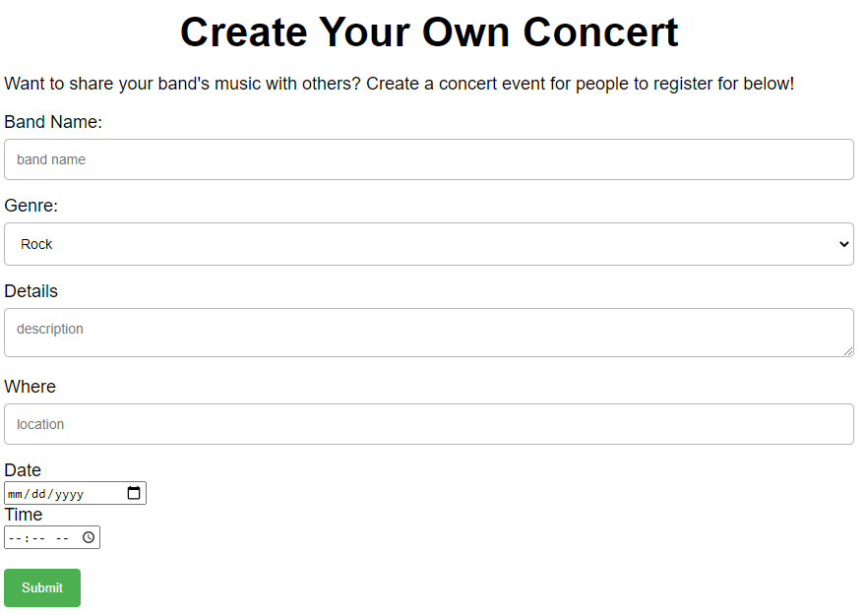

# Logging off:

To log off, all you must do is click the “**Sign Out”** link in the top right corner on the navigation bar. This will redirect you to the home page.